How to Use eTRAKiT to Check Your Zoning
Visit Mendocino’s eTRAKiT website here:
https://etrakit.mendocinocounty.org/eTRAKiT3/
If your site is in one of the following zones, you CANNOT cultivate cannabis.
No cultivation in:
- RL: Rangeland
- FL: Forest Land
- TP: Timber Production
- Select “Search” under Properties
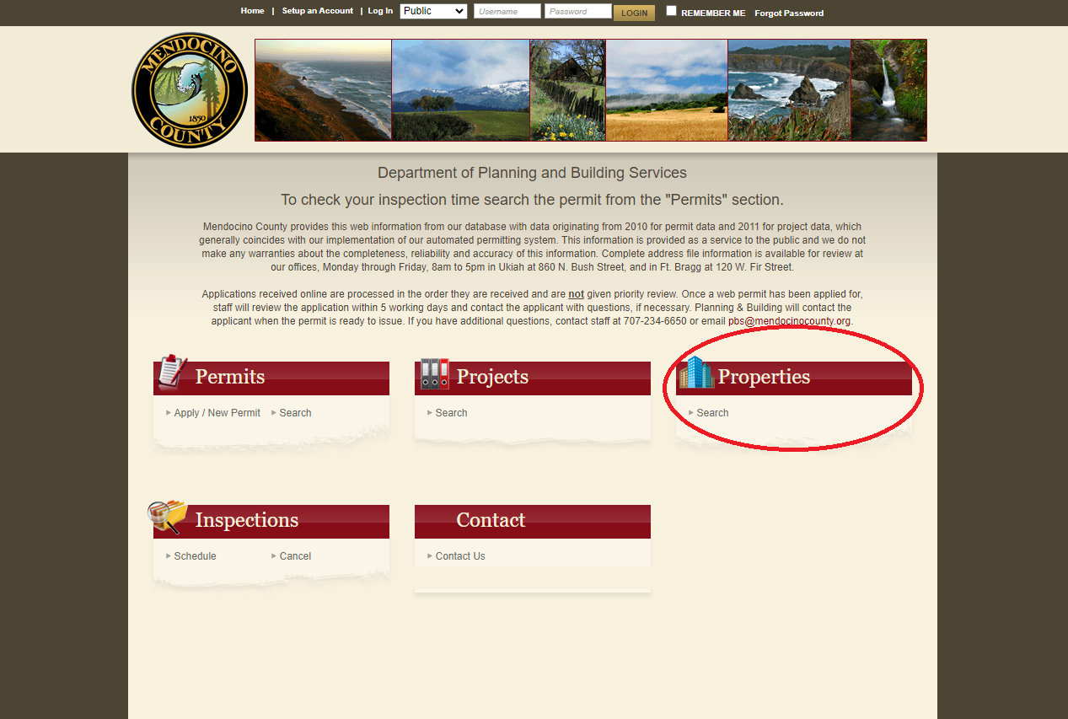

- Enter your site address (or APN) and select “Search”
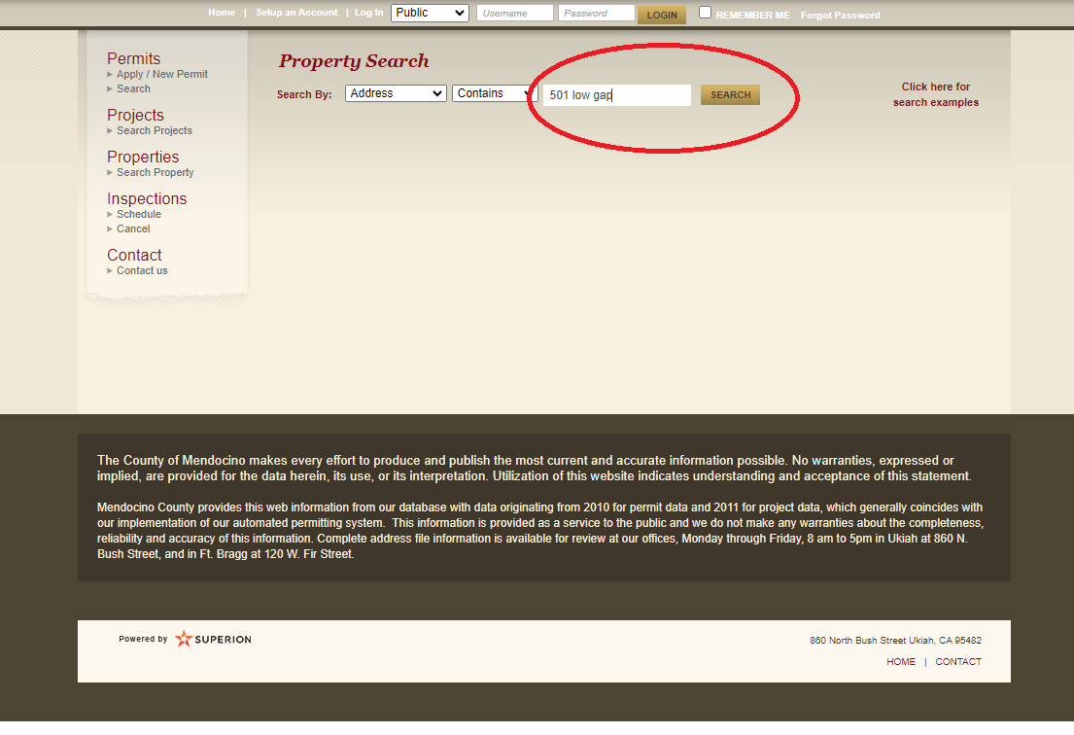
- Select the correct site address by double-clicking
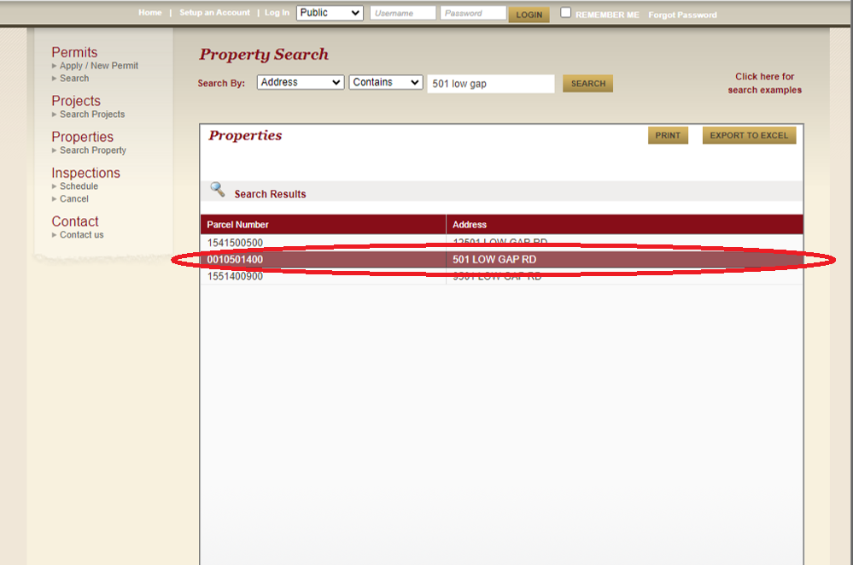
- Select the “Land Use” tab
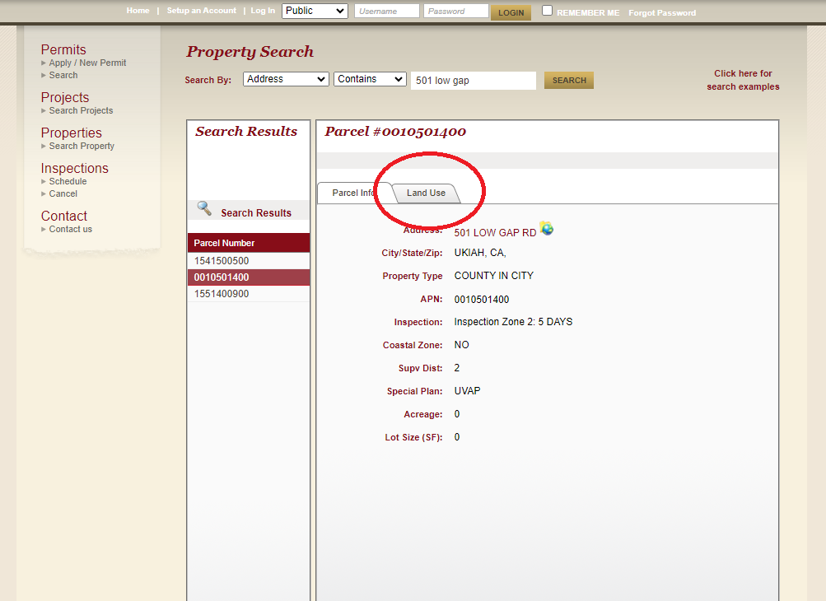
- Check for the zoning code***
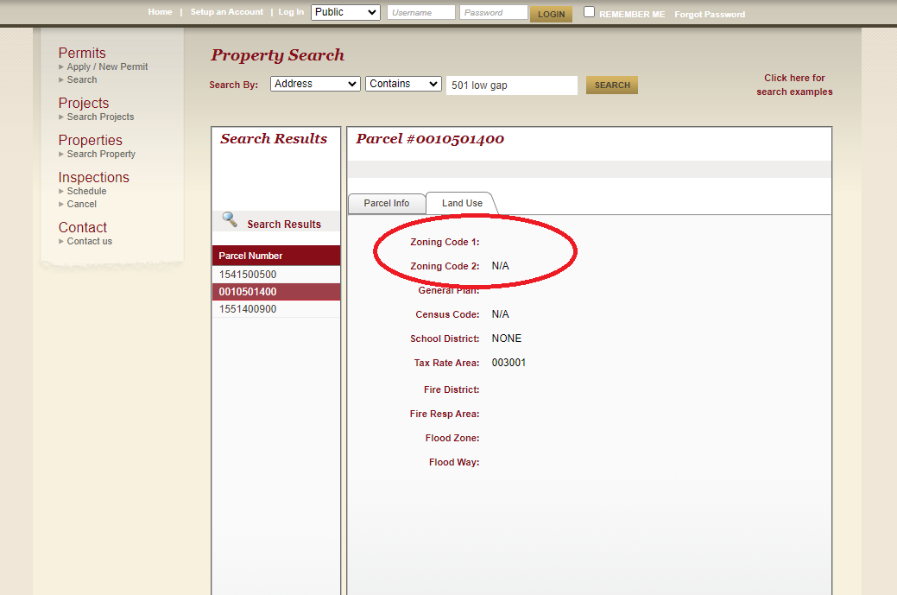
***Should your site address not populate, or your zoning code not be listed (see example above), please call the Assessor’s office to retrieve your zoning code.
Mendocino County Assessor’s Office: (707) 234-6800

