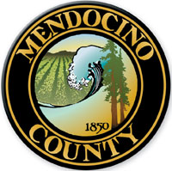

Jim Donnelly
Agricultural Commissioner
Sealer of Weights and Measures

COUNTY OF MENDOCINO
DEPARTMENT OF AGRICULTURE
890 N. Bush Street Ukiah, CA 95482
PHONE (707) 234-6830
FAX (707) 463-0240
agcomm@mendocinocounty.org
www.mendocinocounty.org/ag

Mendocino County Department of Agriculture
Industrial Hemp Agreement
This Agreement is entered by and between:
The County of Mendocino Department of Agriculture
-and-

Mendocino County Industrial Hemp Applicant/Cultivator

________________________________________________
Applicant Signature and Date

- Applicant agrees to all Mendocino County Industrial Hemp Pilot Program requirements
outlined in Mendocino County Code 10A.18, Mendocino County Industrial Hemp Pilot Program RFP, and all Federal and State Industrial Hemp Laws and Regulations.

______________________________________________
Applicant Signature and Date

- Applicant agrees to all cost and fees incurred from Department of Agriculture Inspections, Pre-harvest laboratory analysis fees, destruction and/or abatement if there is a need. Applicant agrees to two (2) mandatory Department of Agriculture Inspections and inspector fees based on submitted inspector hourly rate.

___________________________________________________
Applicant Signature and Date

__________________________________
Mendocino County Department of Agriculture

