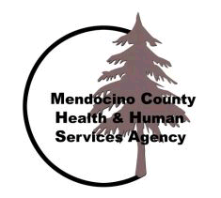
Mendocino County Behavioral Health and Human Services Agency
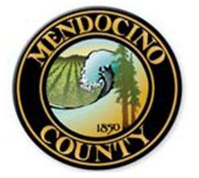
Healthy People, Healthy Communities

2015/2016 Schedule
Forums for Mental Health Services Act

As part of its Stakeholder Participation Process, Mendocino County is convening a series of stakeholder meetings for clients, consumers, their families, county staff, organizational providers, and the community. The County is committed to ensuring stakeholder input is part of its annual program and budget discussion.

Children & Families and Transitional Youth Forums have been combined and now held on the same time as the Adult & Older Adult.
Please note the Forums are at different locations and times throughout the Fiscal year.

July 8, 2015  Noon - 1:30  Manzanita Services Willits  286 N. School St.  Willits, CA 95490 | July 29, 2015  10:30 - 12:00  Pt. Arena Library  225 Main St.  Point Arena, CA 95428
August 12, 2015  Noon - 1:30  Hospitality & Wellness Center  101 No. Franklin St.  Fort Bragg, CA 95427 | *Tuesday, September 15, 2015  Noon – 1:30  Manzanita Services Ukiah  270 N. Pine St.  Ukiah, Ca 95482
October 14, 2015  1:00 - 3:00  Anderson Valley Health Center Conference Ctr.  13500 Airport Rd.  Boonville, CA 95415 | *Tuesday, November 10, 2015  2:00 – 4:00  Laytonville Family Resource Center  Harwood Hall  44400 Willis Ave.  Laytonville, CA 95454
Wednesday, December 9, 2015  11:00 - 1:00  Yuki Trails Hunan Services  Yuki Trails Conference Room  23000 Henderson Rd.  Covelo, CA 95428 | Wednesday, January 13, 2016  12:00 - 2:00  Hopland Band of Pomo Indian’s Rancheria  3000 Shanel Rd.  Hopland, CA 95449
Wednesday, February 10, 2016  Noon – 2:00  HHSA – Conference Room 1  1120 So. Dora St.  Ukiah, CA 95482 | *Suicide Prevention week Story Board Tour is September 7th – 10th  *Wednesday September 16th is the Mental Health Board Meeting  *Wednesday November 11th is Veteran’s Day

Please contact Robin Meloche, MHSA Coordinator, Behavioral Health and Recovery Services, with your questions at (707) 472-2332 or melocher@co.mendocino.ca.us 